**Bug Report**

**Issue 1:**

**Bug Report:**

**Overlapping Issue in Line Chart Representation on Case Category Page when Zooming Out**

**Summary:**

when the user zooms out on the page, the line chart on the Case Category page encounters an overlapping issue, causing the chart elements to become misaligned or distorted.

**Steps to Reproduce:**

1. Open the application in a browser.(<https://inerg-test.web.app/>)

2. Select the state in the state dropdown field.

3. Navigate to the **Case Category** page.

4. Locate the **Line Chart** representing case data.

5.Zoom out the page (mouse hover)

6. Observe the overlapping or misalignment of the line chart elements (e.g., labels, data points, lines).

**Expected Result:**

The line chart should adjust properly when zooming out, maintaining its readability and layout without any elements overlapping or distorting.

**Actual Result:**

Upon zooming out, the line chart becomes distorted with overlapping labels, lines, or data points, making the chart hard to read or understand.

**Impact:**

* The readability of the line chart is compromised, which can confuse users and make data interpretation difficult.
* This issue affects the user experience when trying to view and analyze case data visually.

**Environment:**

* **Browser:** (Chrome, Firefox)
* **Browser Version:** (Chrome 132.0.6834.110)
* **Operating System:** (Linux)

**Screenshot**

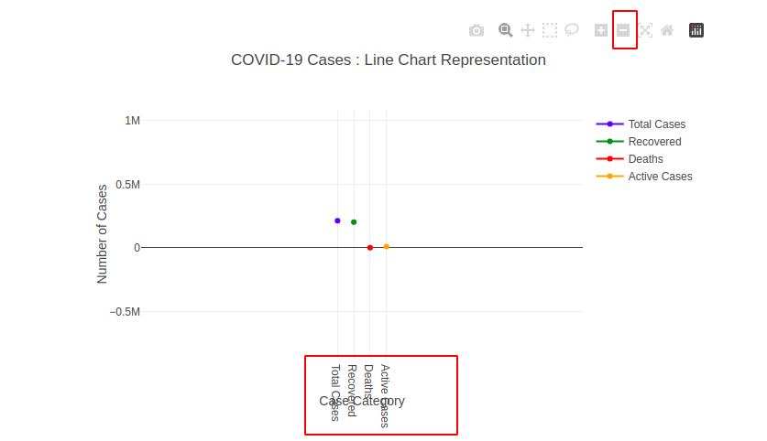

**Priority:**

Low

**Additional Notes:**

* The issue appears specifically when zooming out, but the chart works fine at 100% zoom.
* The issue may be caused by CSS styling or responsive design handling in the line chart component.
* The chartts responsiveness and scaling may need adjustment to prevent overlap at different zoom levels.

**Issue 2:**

**Bug Report:**

**responsive Issue with Dropdown Field in Mobile View**

**Summary:**

When testing the mobile view, the dropdown field does not adjust correctly and fails to cover the intended mobile view, causing a responsive layout issue.

**Steps to Reproduce:**

1. Open the application on a mobile device or simulate mobile view in the browser.

(<https://inerg-test.web.app/> )

2. Navigate to the page containing the **dropdown field**

3. Observe the dropdown field behavior when interacting with it.

4. The dropdown field fails to cover the appropriate mobile screen width, leading to an improper display.

**Expected Result:**

The dropdown field should properly adjust to fit within the mobile view, ensuring a user-friendly experience. It should expand correctly and maintain the mobile-responsive layout.

**Actual Result:**

The dropdown field does not properly cover the mobile view and may overlap other elements, causing misalignment or a broken layout. This results in a poor user experience and difficulty in interacting with the field.

**Impact:**

* The dropdown field is not usable in mobile view, which can affect users' ability to interact with important elements.
* The issue leads to a broken or misaligned layout on mobile devices, reducing the overall usability of the application on smaller screens.

**Environment:**

* **Device:** (Android Galaxy S21)
* **Browser:** (firebox, Chrome)
* **Screen Resolution:** 320* 459 for mobile view simulation

**Screenshot:**

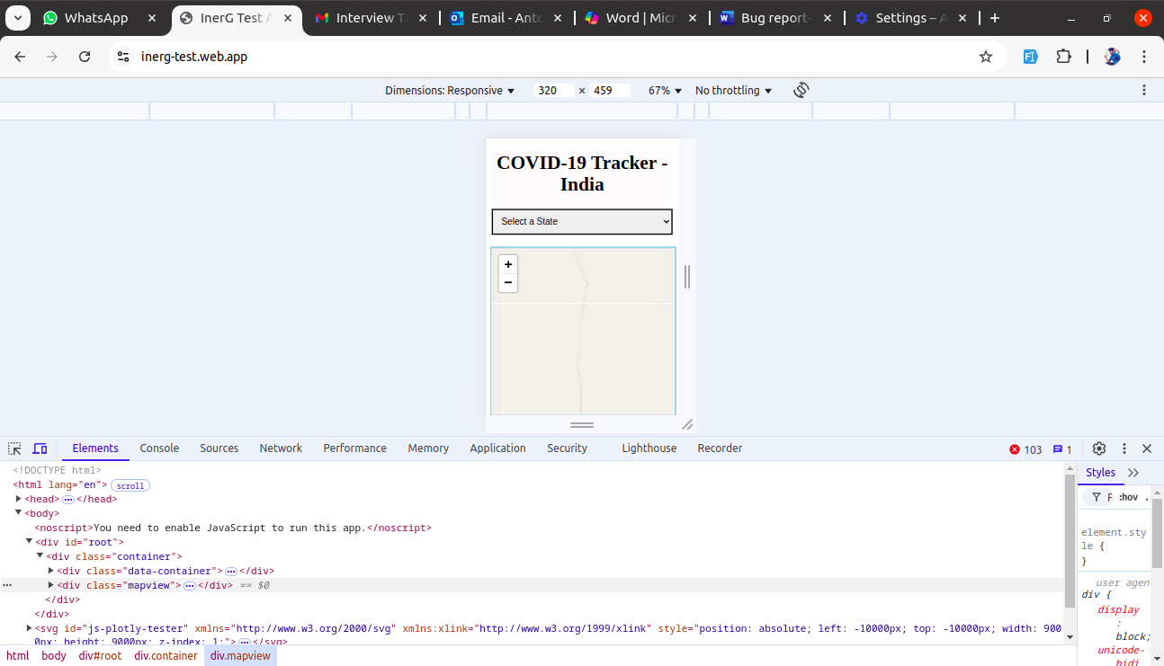

**Priority:**

Medium

**Additional Notes:**

* The issue seems to occur only when viewing the dropdown on mobile devices, not in the desktop version.
* The problem may be caused by CSS or a lack of proper media queries for mobile responsiveness.